**DATABASE ASSESSMENT**

(Q.1) Consider an example where there’s an account holder table where we are doing an intra-bank transfer i.e. a person holding account A is trying to transfer $100 to account B.

* INSERT INTO `account_holder` (`acc_number`, `acc_name`, `city`, `contact`, `date_of_create`, `status`, `balance`, `branch_id`, `type_of_acc`) VALUES (NULL, 'AnkitKumar Dakaniya', 'Ahmedabad', '9099777400', '2023-07-20', b'1', '5000000', '2', 'savings');

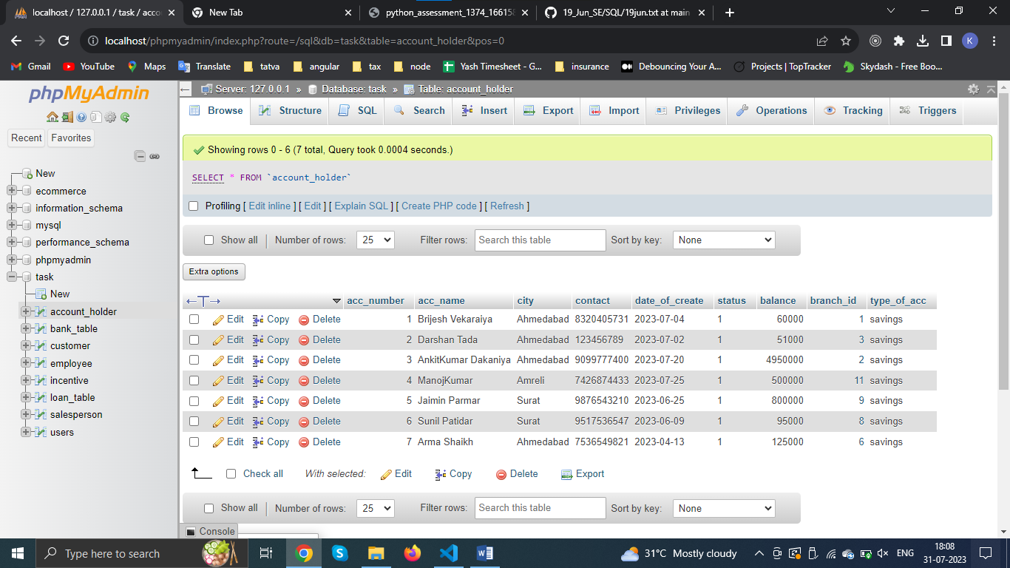

START TRANSACTION;

UPDATE account_holder SET balance = balance - 100 WHERE acc_number = '7';

UPDATE account_holder SET balance = balance + 100 WHERE acc_number = '6';

COMMIT;

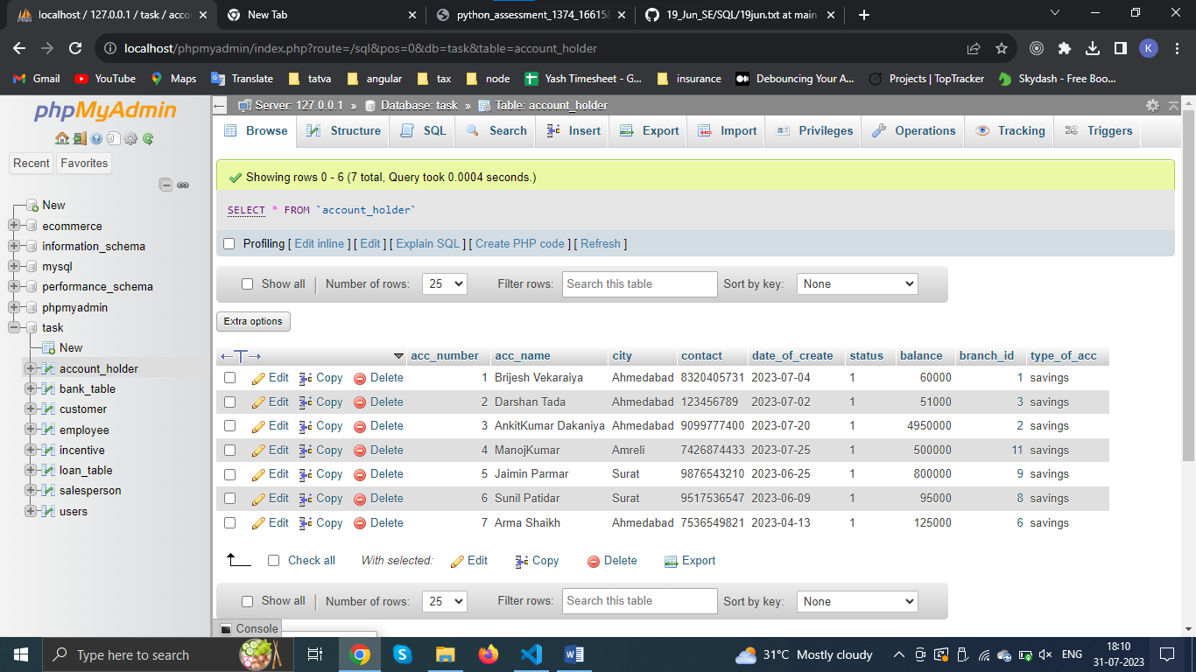

Q.2 Also fetch the details of the account holder who are related from the same city

* SELECT * FROM account_holder where city = 'Ahmedabad' OR city = "surat" OR city = 'Amreli' order by city;

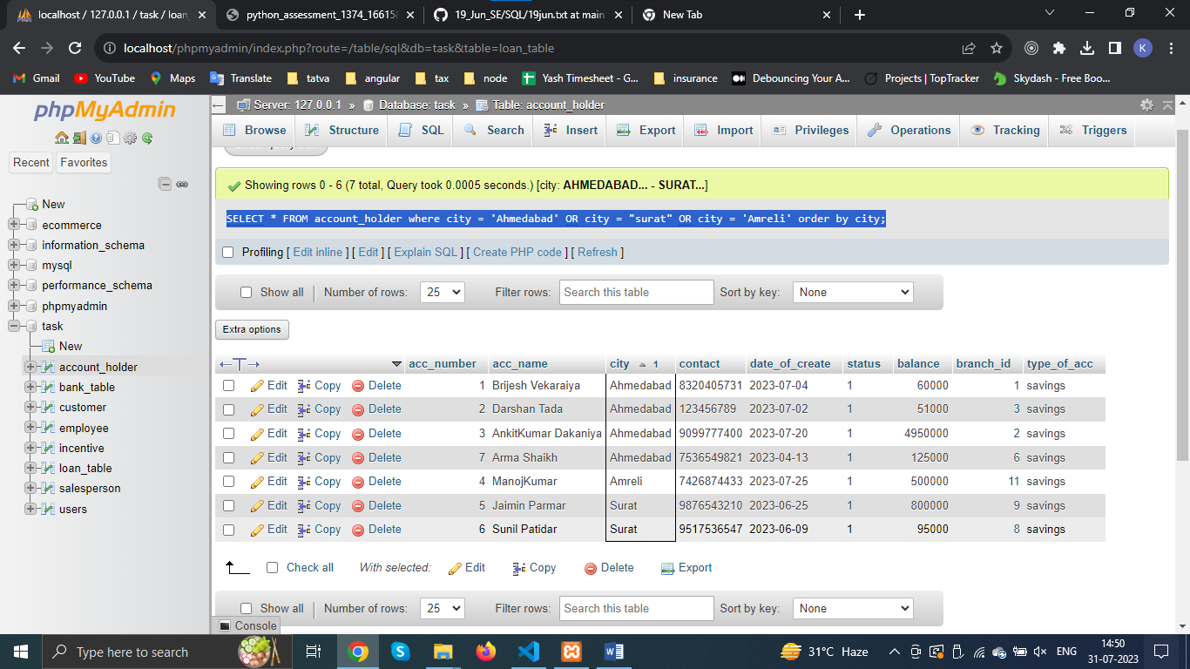

* SELECT * FROM account_holder GROUP BY city,branch_id;

––––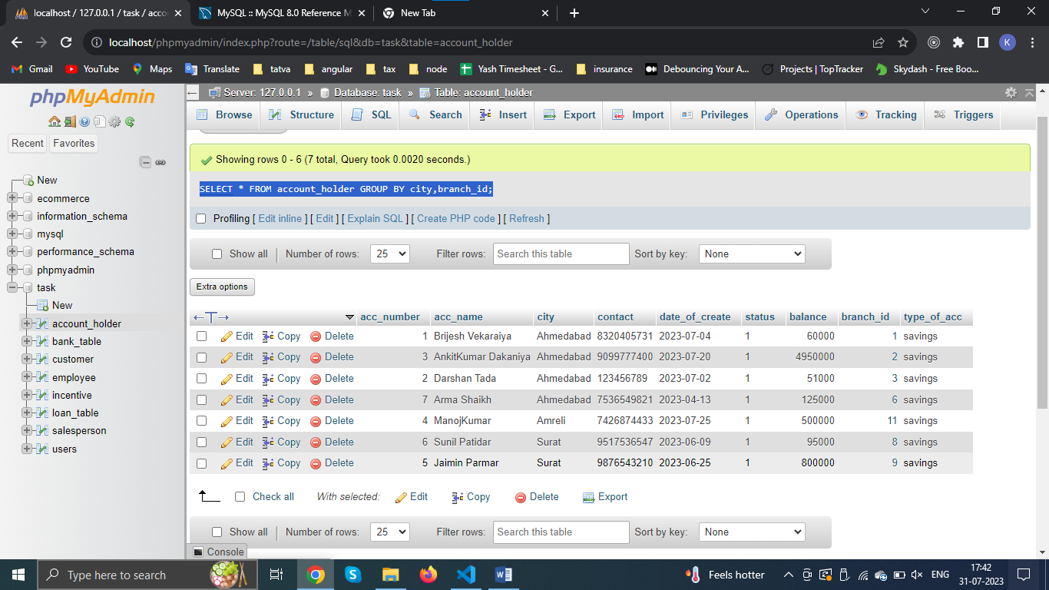

(Q.3) Write a query to fetch account number and account holder name, whose accounts were created after 15th of any month

* SELECT acc_number,acc_name,city,date_of_create FROM `account_holder` WHERE day(date_of_create) > 15;

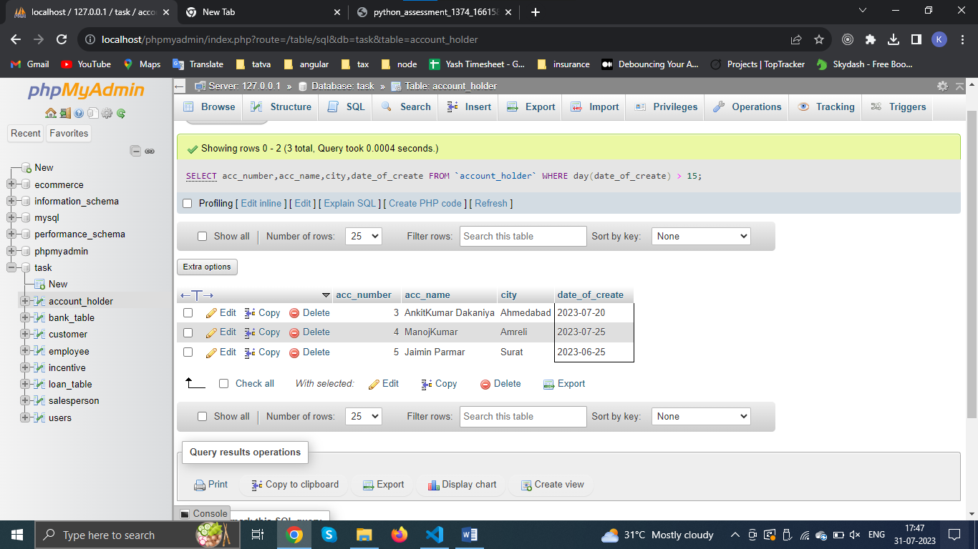

(Q.4) Write a query to display the city name and count the branches in that city. Give the count of branches an alias name of Count_Branch.

* SELECT branch_city,COUNT(branch_id) as branch_count from bank_table group by branch_city;

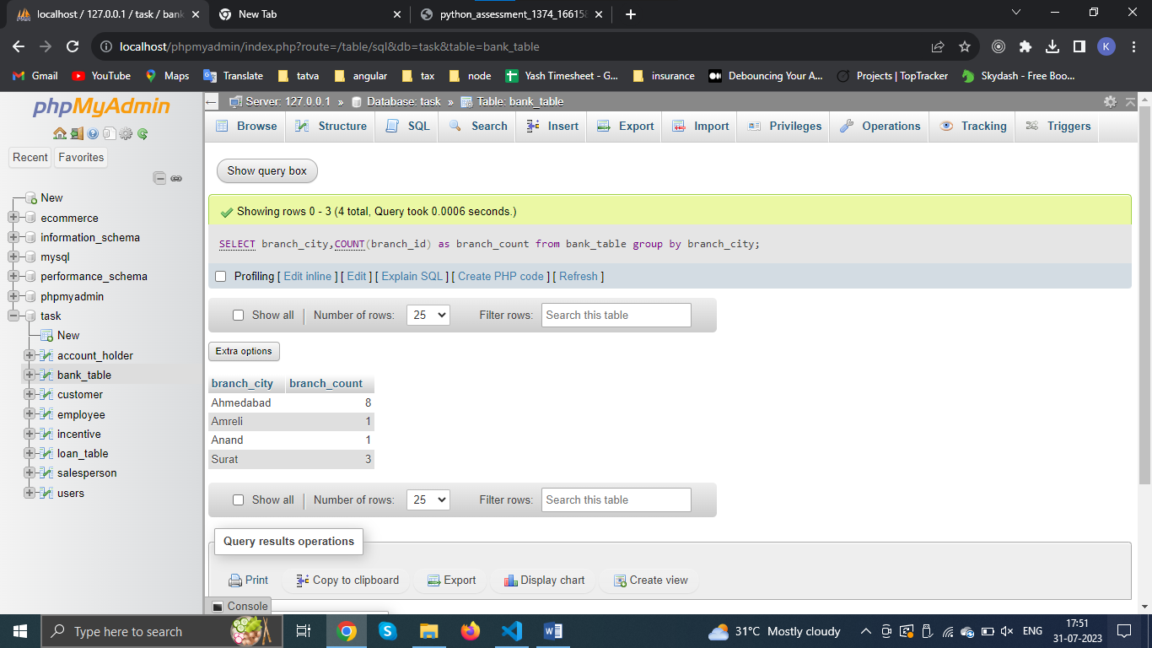

(Q.5) Write a query to display the account holder’s id, account holder’s name, branch id, and loan amount for people who have taken loans.

* SELECT loan_table.acc_id,account_holder.acc_name,loan_table.loan_amount,loan_table.branch_id,account_holder.city FROM `loan_table` JOIN account_holder on loan_table.acc_id = account_holder.acc_number;

